Inquiry Demonstration Plan
Lesson Title: | Extraterrestrial life. | Lesson # | 1 | Date: | July 21, 2020
Name: | Yu | Subject(s): | Science | Grade(s): | 11

Rationale & Overview
Why does this topic matter to students?
How does this lesson fit within the larger inquiry project?
How does this project incorporate the inquiry cycle?

I want students to start a topic about whether there will be extraterrestrial life. Dominican friar giordano Bruno, announced that the universe contains the same world with us infinite, he directly violates the religious doctrine later during the inquisition, he was burned at the stake, in part because he dared to question the unique position of the earth (Rugheimer, 2019). To this day, the debate continues in a restrained fashion. For some, the size of the universe makes it impossible to form a single life. For others, the extraordinary complexity of life on Earth proves its uniqueness. The scientific community has yet to accept the evidence for extraterrestrial life as real, and has failed to take a clear-cut stand on the existence of other life forms. It is worth noting that bringing extraterrestrial belief to a supernatural scale are disputed (Dagnall, 2011).

This topic is based on the k-12 item of the big ideas in the BC Curriculum. Students are expected to be able to demonstrate a sustained curiosity about a scientific topic or problem of personal interest, and Identify questions to answer or problems to solve through scientific inquiry. The key to this topic is how do students verify their conclusions through their own research and inquiry, and in this process, students will inevitably investigate relevant knowledge across disciplines. This further enhances their ability to imagine and connect with their surroundings (Jardine et al., 2003). Students have opportunities to develop personal and social awareness of their roles and responsibilities with respect to the environment. By cultivating an appreciation for the field of science, students can recognize opportunities to apply their knowledge in their everyday lives or contribute to science in their future careers.

This topic belongs to a small part of astronomical knowledge, and explores relevant knowledge from the perspective of our living environment. Teachers can guide students to explore larger topics based on this.

The questions are used to introduce the direction of students' investigation, then the group investigation, discussion and conclusion are made, and finally the group shows the results by presentation.

Key Questions For Inquiry
Core Question & Supporting Questions for Inquiry Project | Question(s) Addressed in This Lesson
What kind of relationship between earth and solar system? | 1. Draw the position of the Earth in your mind in the solar system.  2. Watch this video and describe how you feeling. https://www.youtube.com/watch?v=libKVRa01L8  3. Let each student observe stars with an astronomical telescope.
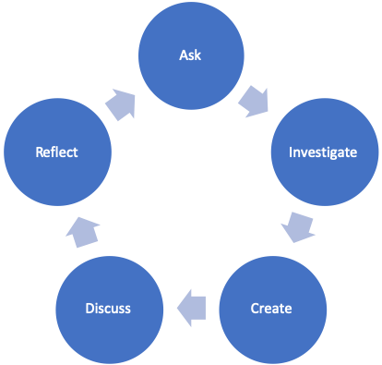

Inquiry Approach and Rationale
Mainly through the use of network resources to inquiry because will involve knowledge of other disciplines.

Core Principles of Effective Teaching (Sharon Friesen) Focus on one or more core principles in the lesson
Core Principle 1: Effective teaching practice begins with the thoughtful and intentional design of learning that engages students intellectually and academically.  *What aspects of the inquiry are the most challenging and meaningful for students? | This is not a topic that people often contact with, and it is far away from our life. Therefore, it requires students to construct the whole knowledge system from scratch in a short time, and also involves other knowledge systems, such as social science and life science. However, it can fully mobilize students' imagination and ability to relate to other disciplines.
Core Principle 2: The work that students are asked to undertake is worthy of their time and attention, is personally relevant, and deeply connected to the world in which they live.  *What makes this inquiry valuable, meaningful, and “alive” for the students and teachers? | This is an open question, and allowing students to explore on their own can bring new ideas about how to look at the problem, as well as improve their view of the world.
Core Principle 3: Assessment practices are clearly focused on improving student learning and guiding teaching decisions and actions.  *How do I define learning and success in this inquiry? How is learning expressed and articulated in peer, self and teacher assessments? | As long as students can identify the problem, choose the perspective and then inquiry the relevant theory through the network or other methods, in which interdisciplinary connections are designed, and finally come to a conclusion, the completion of such a process is considered a success.
Core Principle 4: Teachers foster a variety of interdependent relationships in classrooms that promote learning and create a strong culture around learning.  *How do I connect students with each other, with experts in the field, with larger communities and nature, and across disciplines? | The ability of students to learn to get along with their peers, accept or persuade others to accept their Suggestions by assigning groups of three to them. Through interdisciplinary research to connect experts in related fields.
Core Principle 5: Teachers improve their practice in the company of peers.  *How do I reflect on the inquiry together, and/or collaborate with others? | In this process, help students narrow down their scope of discussion to prevent the topic from being too big and make it impossible to inquiry, and to ensure that each group can explore the issue from a different perspective.

BC Curriculum Core Competencies
Communication | Thinking | Personal & Social
Demonstrate a sustained intellectual curiosity about a scientific topic or problem of personal, local or global interest. | Demonstrate a sustained intellectual curiosity about a scientific topic or problem of personal, local or global interest. | Contribute to care for self, others, community, and world through individual or collaborative approaches.

BC Curriculum Big Ideas (STUDENTS UNDERSTAND)
The solar system is part of the Milky Way, which is one of billions of galaxies.

BC Curriculum Learning Standards
(STUDENTS DO) | (STUDENTS KNOW)
Learning Standards - Curricular Competencies | Learning Standards - Content
Questioning and predicting;  Planning and conducting;  Processing and analyzing data and information  Evaluating;  Applying and innovating;  Communicating. | the overall scale, structure, and age of the universe;  the position, motion, and components of our solar system in our galaxy.

BC Curriculum Indigenous Connections/ First Peoples Principles of Learning
How will I incorporate Indigenous knowledge and principles of learning?
Learning is holistic, reflexive, reflective, experiential, and relational (focused on connectedness, on reciprocal relationships, and a sense of place). It is hoped that students will look at the problem as a whole in the process of searching for information, because this topic contains a lot of interdisciplinary knowledge, and hope that students can solve this problem not only from a biological or astronomical perspective
Learning involves patience and time. I don't think the problems I designed can be solved in class. Students also need time after class to discuss and develop their ideas, self-assess and improve their work. In the final presentation, they need to describe how it is improving over time.

Respectful Relations
How will I invite students of all backgrounds, interests and skills into the inquiry?

Teachers can participate in the discussion of each group and have an equal dialogue with students, and promote group members conversation.

Lesson Activities
Time Allotted |  | Teacher | Students
Invitation | 5min | Introduction of the question. Inform students of the flexibility of answers.
Inquiry | 20min | The teacher raises the predetermined questions and gives some hints. | Let each student observe stars with an astronomical telescope.  Investigate data through the Internet.
Reflection | 20min | As an observer, the teacher will participate in the discussion of each group and help the students to narrow the discussion scope for the report. | Team members began to share ideas and information with each other, and to determine the direction of the group's report.
Discussion | 20min | The teacher began to organize the final discussion and the group began to make presentations in turn. | The group members begin to organize the presentation according to the determined direction to answer the last question (Extra time is needed ).

Materials and Resources
Laptop or tablet computer.

Organizational Strategies
Conducting a survey of this topic in groups of three, students can use all methods to investigate their points of interest, starting from the point of view that they think the answer can be derived. In this process, the teacher will guide them to narrow down the scope of discussion and try to let each group see the topic from a different perspective. In the process of student investigation, it may involve not only scientific knowledge but also social subjects. As students explore problems, interdisciplinary connections will deepen their understanding of other disciplines and generate a richer imagination, which further enhances their ability to imagine and connect with their surroundings (Jardine et al., 2003). I think that when students get to work together, they become more engaged and learn how to get along with each other, just like they will have to do in the real world. In groups, students that struggle can get help from other students, and they do not feel alone in their learning. When a group of people exchanges views with each other, observing problems from different perspectives deepens their understanding of the goal of inquiry (Bai, 2005). I believe in learning is that it is an effective way for students to work together to deal with real-life because it is based on Vigotsky’s constructivism (Verenikina, 2003). Vigotsky believes that when people actively seek new information, they will learn best through meaningful interaction with their surroundings; he does not believe that people will learn in isolation. He said that building new information requires guidance and support from adults or more capable peers.

Proactive, Positive Classroom Learning Environment Strategies
Continuous monitoring and recording of student progress during interventions to guide decisions for both the student (e.g., further assessment, individualized planning) and the teacher (e.g., using small-group or one-to-one learning contexts, topics for professional development).

Handout
My topic is extraterrestrial life. Let me briefly introduce the process of today's course. The course will focus on four core issues. I plan to develop this topic in four classes, but for time reasons we have to reduce it to 450minutes, and it was originally necessary for different groups to carry out this topic, and in the end, and different groups are required to this topic. The final presentation will be made by members of different groups. And the tools you use can be done by laptop. After my question is sent out, you have 20 minutes to make inquiries online and 10 minutes to discuss, finally 10min to presentation. As an observer, I will give the necessary hints, then when you start it, I’m not going to have any directional questions. Everything is based on your inquiry and discussion. We are just assuming that there is such an event or topic, so relax, we don't necessarily have to come to any conclusions and just enjoy it.
Draw the position of the Earth in your mind in the solar system. 5min
https://www.youtube.com/watch?v=libKVRa01L8 5min
- Now we have a general understanding, What kind of relationship between earth and solar system? 20min inquiry+10min discussion
(hint: the sun provides the energy)
You can find the answers individually, then discuss in groups, and finally report
You can investigate according to your own ideas. Any aspect.
- What are the existing life forms on earth? What other forms of life do you think might exist, or could exist beyond Earth? 20min inquiry+20min discussion (hint: Most of the oxygen in living cells of all life on Earth, including humans, is actually in the form of water,) 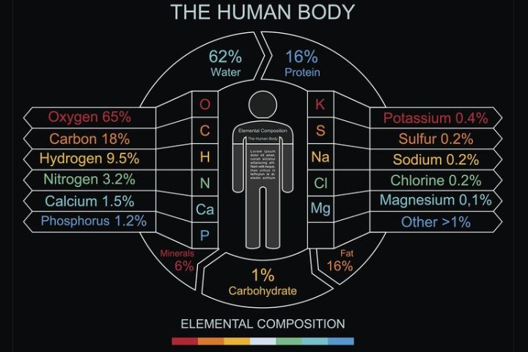
- What are the chances that there is extraterrestrial life? what might that look like? 20min inquiry+10min discussion
In fact, there is still no definitive answer to this question, but I hope that students can inquiry it from a multi-directional and interdisciplinary perspective. For example, from the perspective of the composition of life, the size of the universe, the probability of mathematical calculation, as well as the political and economic interests in social study, which will involve the study of history. That's why there are multiple groups, we need to discuss in multiple groups, which will not only reduce the workload of students, but also allow more ideas to communicate with each other. The communication ability is also what we hope students can improve. Although the course belongs to science, the interdisciplinary contact, imagination and in-depth self-directed learning are what I hope this course will bring to students.

Reference
Bai, H. (2005). What is inquiry. In W. Hare & J. Portelli (Eds.), Key questions for educators (pp. 45–47). Halifax: EdPhil Books
Dagnall, N., Drinkwater, K., & Parker, A. (2011). Alien visitation, extra-terrestrial life, and paranormal beliefs. Journal of Scientific Exploration, 25(4), 699–720.
Jardine, D., Clifford, P., Friesen, S. (2003). Back to the basics of teaching and learning. New York: Routledge, https://doi.org/10.4324/9781410606938
Rugheimer, S. (2019). Is there anybody out there? New Scientist, 243(3245), 42–45. https://doi.org/10.1016/s0262-4079(19)31632-x
Verenikina, I. (2003). Understanding scaffolding and the ZPD in educational research. https://www.researchgate.net/publication/267778614_Understanding_Scaffolding_and_the_ZPD_in_Educational_Research/citation/download

